**Finding a neighborhood to settle in the Big Apple**

Daniel Wolk

August 22, 2019

1. **Introduction**
   1. **Background**

I am doing a major in International Business with a focus on Financial Services. As I always loved American culture and the big city life, moving to a major city in the US was always a favorable consideration.

For a Finance guy like me, NYC would obviously be the best choice. Therefore the question arises, into which neighborhood in NYC I should settle into.

* 1. **Problem**

The goal of this project is to analyze a data set on various neighborhoods in NYC to figure out in which Neighborhood I should settle into.

* 1. **Interest**

This research is interesting for anyone who is like me and would like to move to the Big Apple.

1. **The Data Set**

Luckily, the data used for this project is available for free on data.gov as JSON file. The data contains several areas of interest in the city of New York.

The JSON file comes in a clean format and can be used for further analysis. However, it is necessary to append this data with the latitude and longitude values of each neighborhood. This step is necessary to be later on able to plot maps of the neighborhoods and do further analysis.

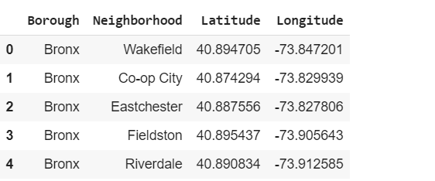

This picture shows the first five rows of the joined dataframe including the boroughs, the neighborhoods and the respective latitude and longitude values.

1. **Methodology**

**3.1 Plotting the first maps**

In the first step we will create a map of New York showing the different parts of the city and the neighborhoods they consist of.

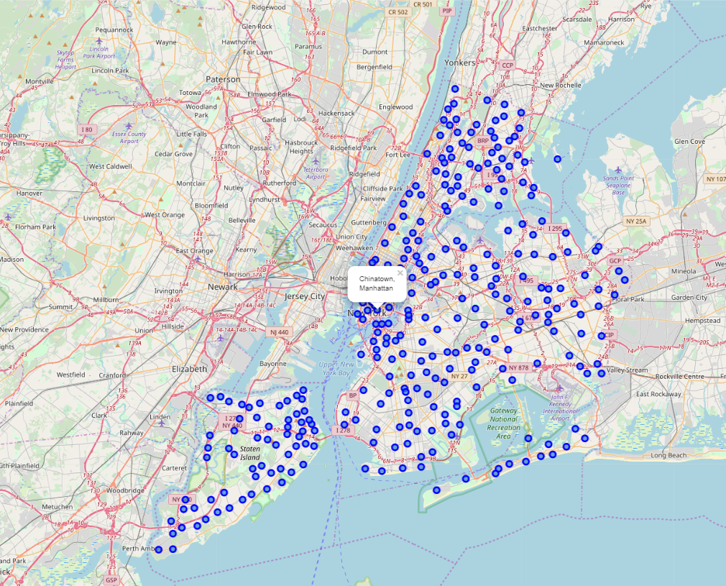

As we can see from this map, there are is an almost infinite amount of neighborhoods in NYC. However, our question remains and that is in which neighborhood should we choose to move to?

To reduce the number of potential neighborhoods to settle into we will focus our research on the borough of Manhattan, since we specified that our goal is to work in the financial industry and the Financial District is in the heart of Manhattan.

In the second step we thus, print a map containing the neighborhoods of Manhattan.

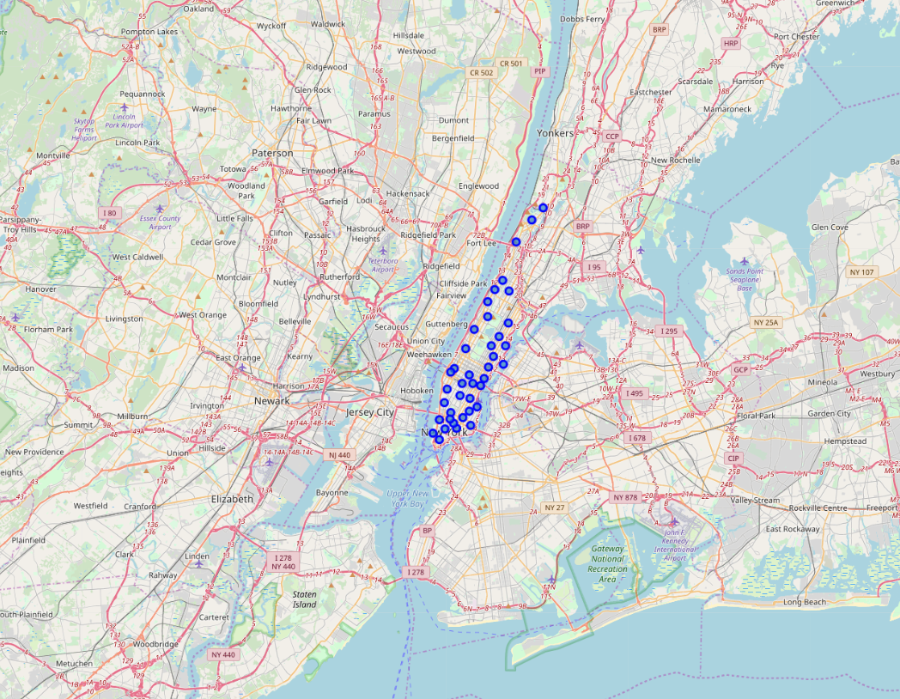

As can be seen the number of potential neighborhoods to move into have already dramatically reduced.

For the next step, we will make a call to the Foursquare API to get information about the venues which are close to the Financial District.

We will use this data to assess the quality of neighborhoods close to the Financial District.

In total, the tool returns 3324 venues in 40 neighborhoods.

To see how many venues have been returned per neighborhood, we group the data by neighborhood and perform a value count.

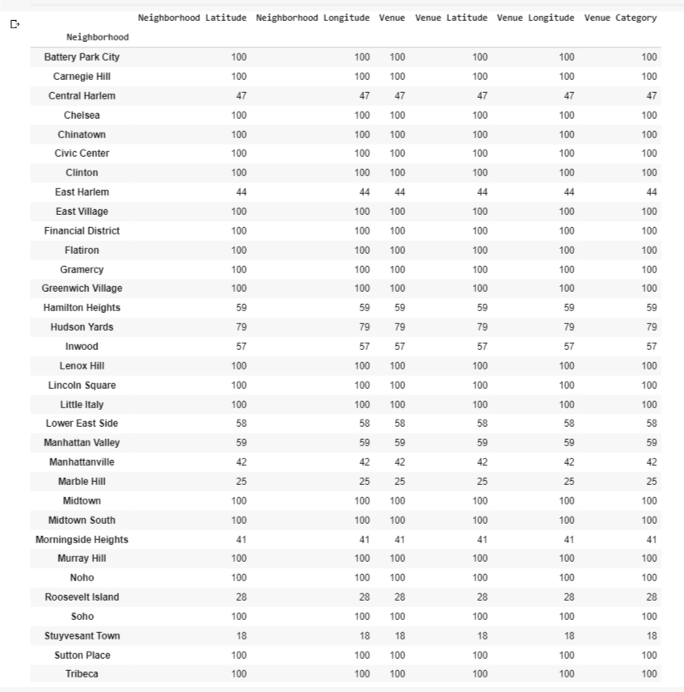

As can be seen from the resulting dataframe there are some neighborhoods that have more venues than others. We assume for this research that a higher number of venues in the neighborhood can be associated with a higher quality of living.

However, the importance of the availability of different kinds of venues depends on the interest of the person interested in moving.

To dig further into our analysis we will adjust the data frame to display the most common venues per neighborhood.

When I am not working with some financial data, I love to work out in the gym.

Therefore in the next step, we will filter for the neighborhoods where the gym is the most common venue.

1. **Results**

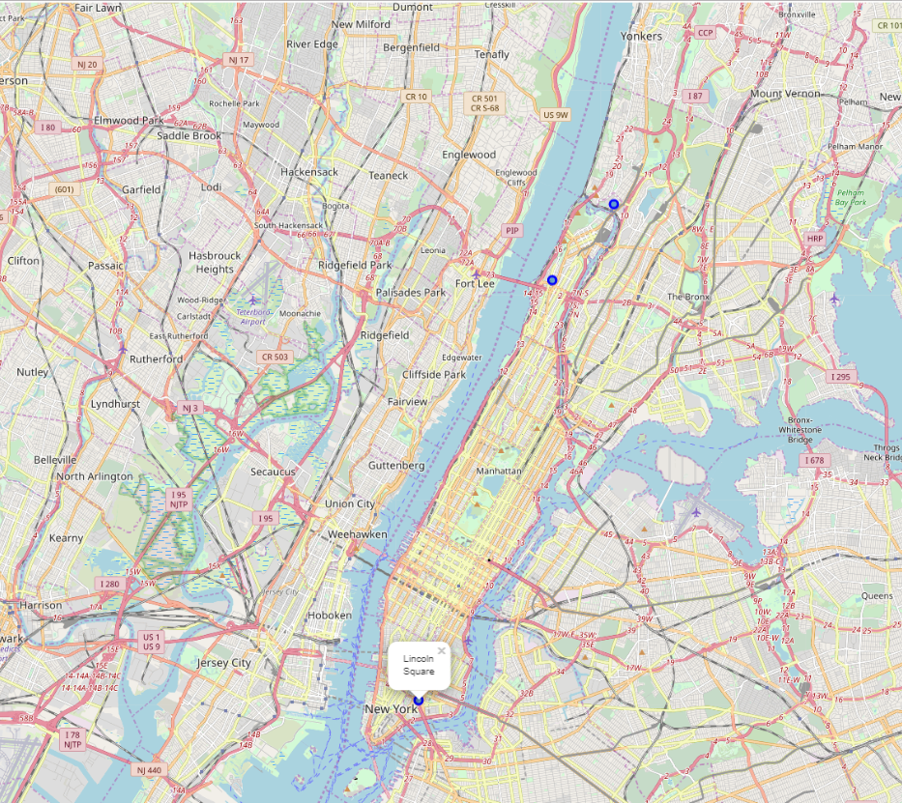

There are three neighborhoods where the gym is the most common venue. Plotting these neighborhoods on the map of Manhattan reveals that Lincoln Square is the closest to the Financial District and will be the area I will move to.

1. **Discussion**

Obviously, not for everyone that moves to Manhattan the most important factors are the amount of gyms and the proximity to the financial district.

Thus we will use k means for clustering to display different venue clusters for the neighborhoods of Manhattan, helping readers to figure out which neighborhood they should move to.

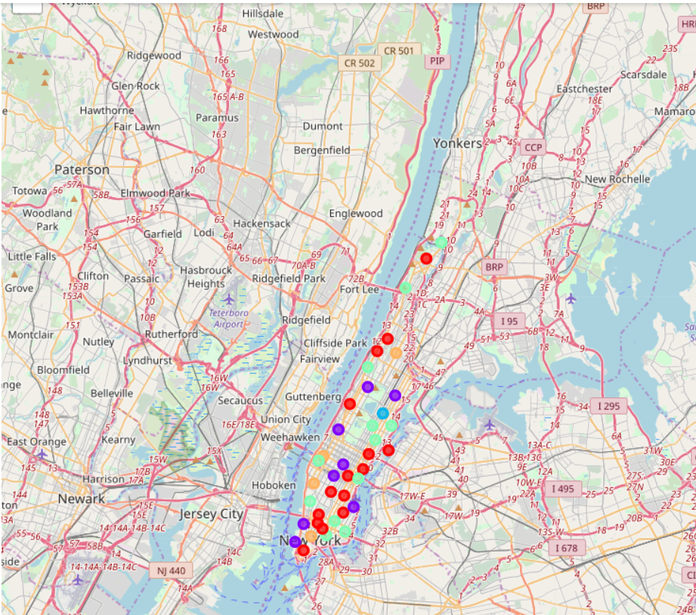

1. **Conclusion**

As can be seen from the research suggesting the right neighboord depends largely on the interests of the person. An interesting future research would be to use a data set of immigrants to New York City, their interests and the neighborhoods they moved to.

This data set could be used to build a recommender system using machine learning for Python, to suggest new arrivers which neighborhood is suitable for them based on job and interests.